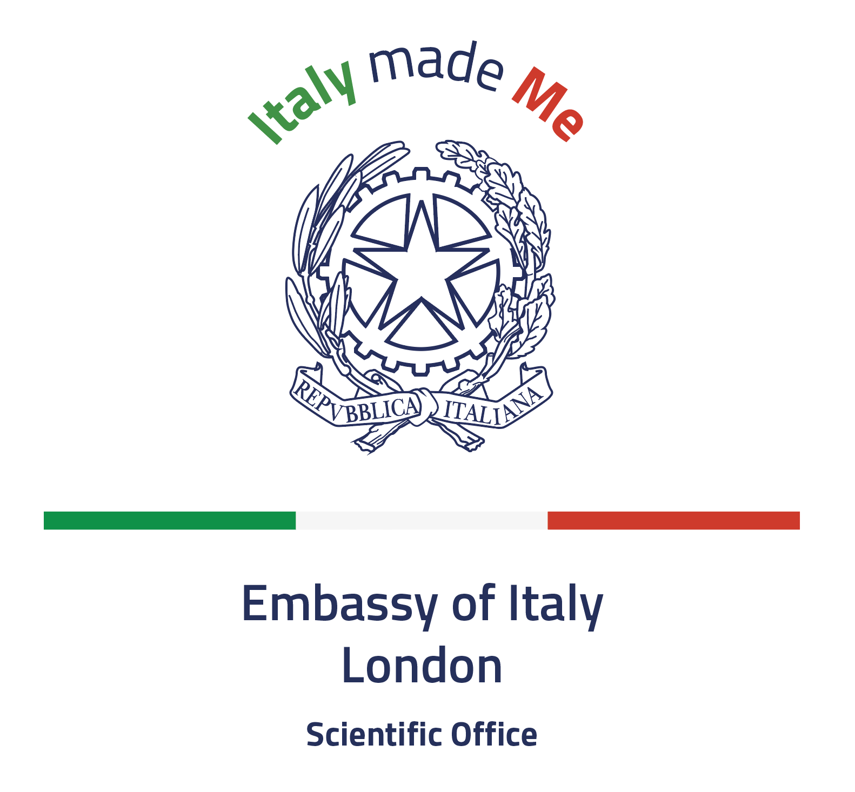
Italy Made Me Awards 2026
Application Form
CANDIDATE NAME:
---------------------------------------------------------------------------------------------------------
Disciplinary field (tick appropriate box):
- Life Sciences
- Physical and Engineering Sciences
- Social Sciences and Humanities
Membership (specify Italian academic/cultural association name):
________________________________________________________________
Research title:
________________________________________________________________
Supervisor and name of the British institution in which the research was carried out:
________________________________________________________________

- CURRICULUM VITAE
Candidate name __________________________________
E-mail __________________________________________________________
Telephone _______________________________________________________
Address _________________________________________________________

Current position of the candidate:
________________________________________________________________
Name and address of the institution to which the candidate belongs:
________________________________________________________________
Awards, honours and/or grants conferred:
________________________________________________________________
________________________________________________________________
Relevant academic/research publications (5 max.):
________________________________________________________________
________________________________________________________________
________________________________________________________________
________________________________________________________________
________________________________________________________________

- EDUCATION
DIPLOMA DI MATURITÀ (or equivalent degree) IN …………………………………………………………………………………………………………………….
Name and place of the institution ………………………………………………………………….
Final grade …………………………………………………………………………………………./100

DEGREE IN ………………………………………………………………………………………….……..
Graduation date: ……………….……………………………………………………………………….
University ……………………………………………………………………………………………..……
Dissertation title …………………………………………………………………………………………
Final grade ….……………………………………………………………………………………../…….

PhD/DOCTORATE IN ………………………………………………………………………………..…
Graduation date ……………….……………………….…………………………………….…………
University ……………………………………………………………………………………………………
Dissertation title: …………………………………………….………………………………………….
Final grade …………………………………………………………………………………………./…….

Candidate signature: Date:

- RESEARCH PROJECT PRESENTATION
Please complete the following sections accordingly:
- State of the Art: statement on the status of the research field (1000 characters max. including spaces);
- Statement on the Research Results (2500 characters max. including spaces);
- Statement on the Impact of the research and its implications for the state of research in its field (1500 characters max. including spaces).
Please note that if the character limit is exceeded, the section will not be evaluated.

- DECLARATION
To be attached on headed paper from the candidate’s institution.
In reference to the attached application for the award programme Italy Made Me, I confirm that the work presented here was primarily conducted by the candidate and was obtained at the following institution:
________________________________________________________________

Candidate name and surname  (in capital letters): | Candidate signature:
Supervisor name and surname (in capital letters) | Supervisor signature:

Date and place:

Please specify main subjects covered.
Please indicate the period of time; Bachelor’s or Master’s Degree etc.
Please indicate period of time of the PhD.

